

**Mawlana Bhashani Science and Technology University**

**Lab-Report**

Report No: 04

Course code: ICT-4202

Course title: Wireless and Mobile Communication Lab

Date of Performance: 11.09.2020

Date of Submission: 18.09.2020

**Submitted by Submitted To**

Nazrul Islam

Assistant Professor

Dept. of ICT

MBSTU.

Name: Rifat-Al-Rashid

ID: IT-16058

4th year 2ndsemester

Session: 2015-2016

Dept. of ICT

MBSTU.

**Experiment No: 04**

**Experiment Name: Protocol Analysis with Wireshark**

**Objectives:**

* Capture live packet data from a network interface.
* Display packets with very detailed protocol information.
* Filter packets on many criteria.
* Search for packets on many criteria.
* Colorize packet display based on filters.
* Create various statistics.

**Capturing Packets:**

By clicking Capture menu the process of capturing will be started. It will show the available interfaces list. Then, we need to start Capturing on interface that has IP address

The packet capture will display the details of each packet as they were transmitted over the wireless LAN.

Capturing can be stopped by clicking on Stop the running capture button on the main toolbar.

**Screenshots:**

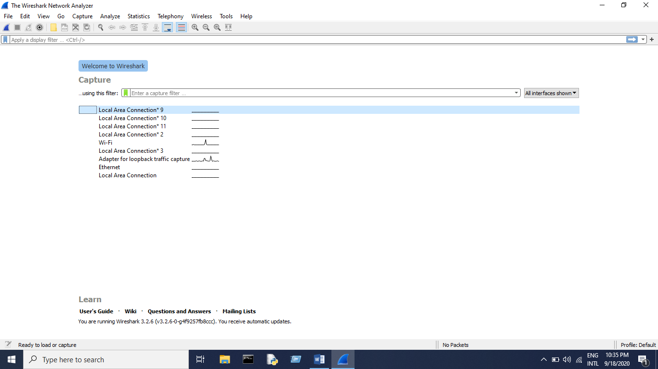

**Figure 01: Wireshark Interface List**

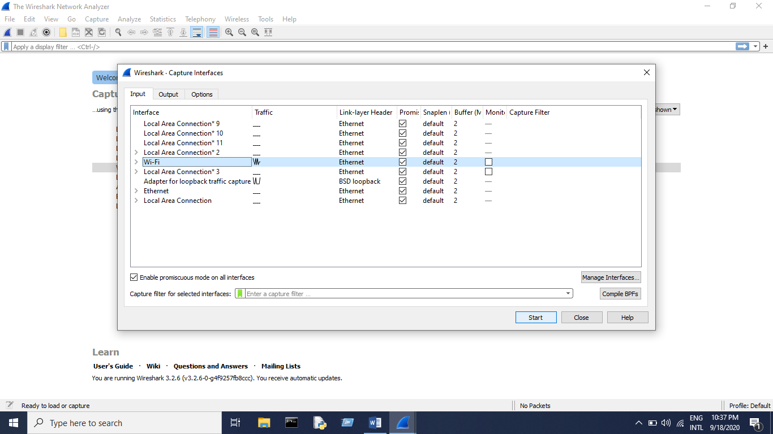

**Figure 02: Start Capturing Interface that has IP address**

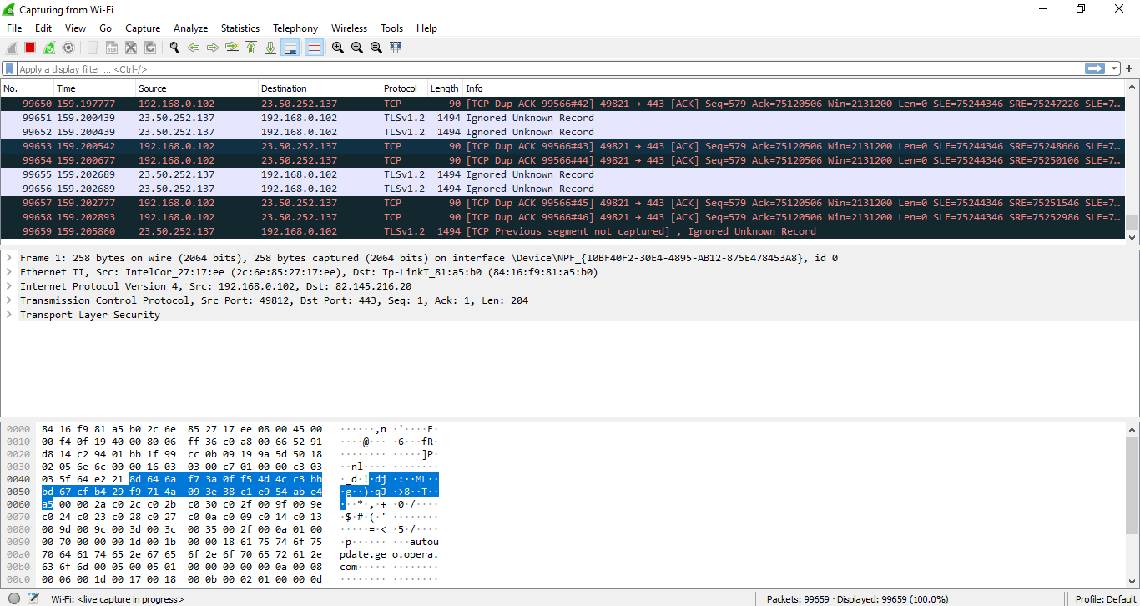

**Figure 03: A sample packet capture window**

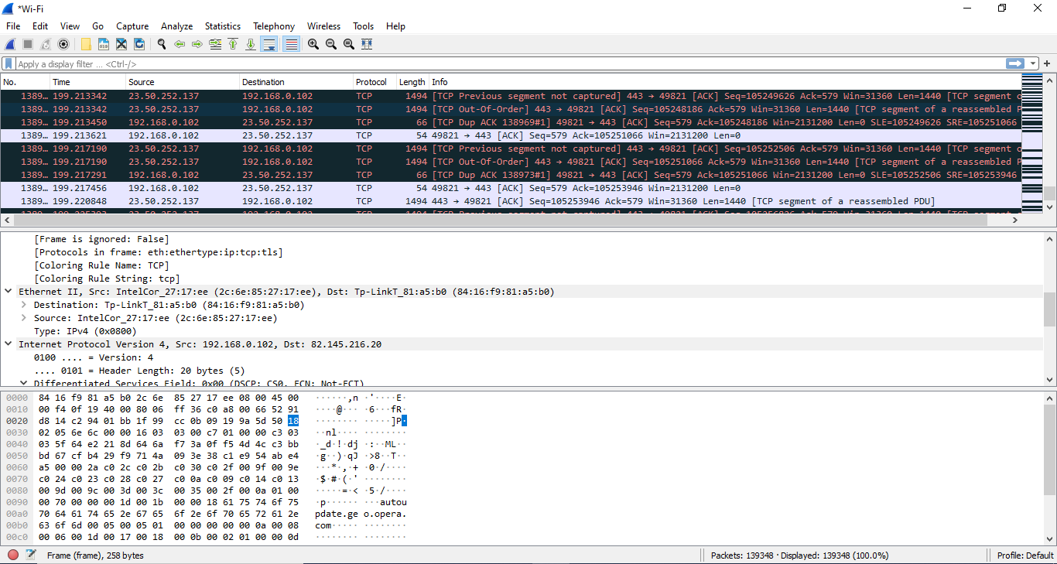

**Figure 04: Stopping Capture**

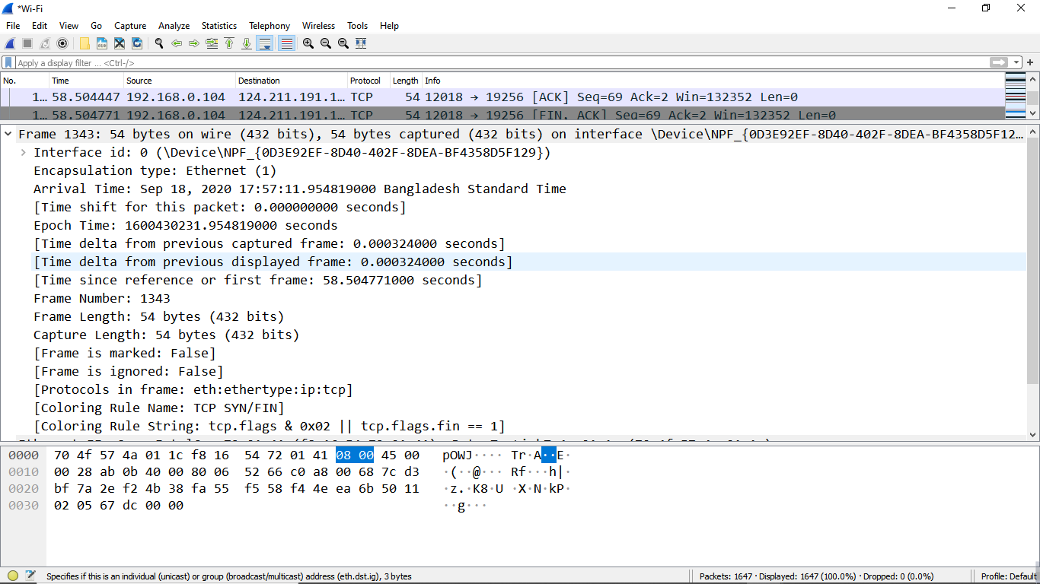

**Figure 05 : Packet Details Pane(Frame segment)**

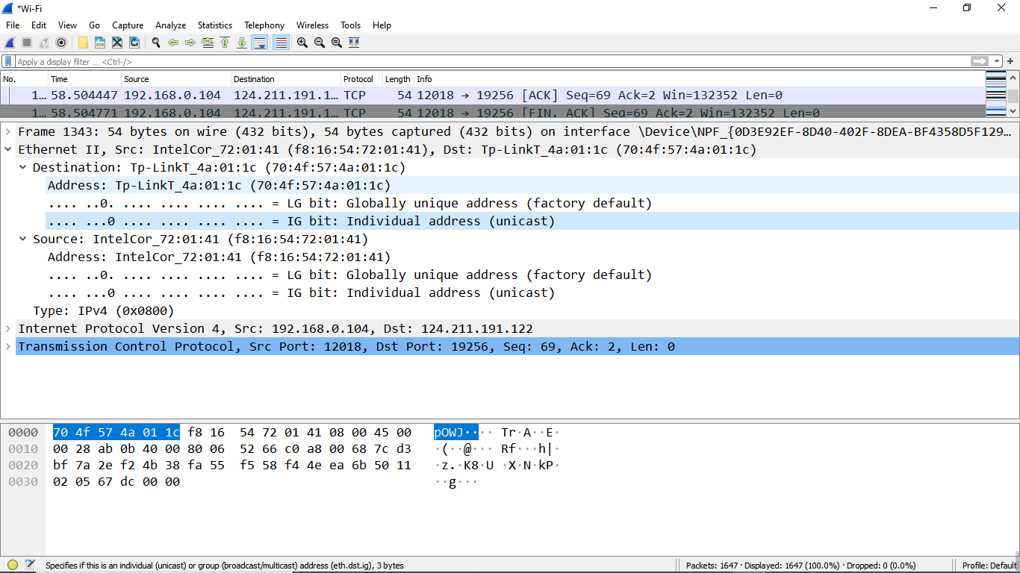

**Figure 06: Packet Details Pane (Ethernet Segment)**

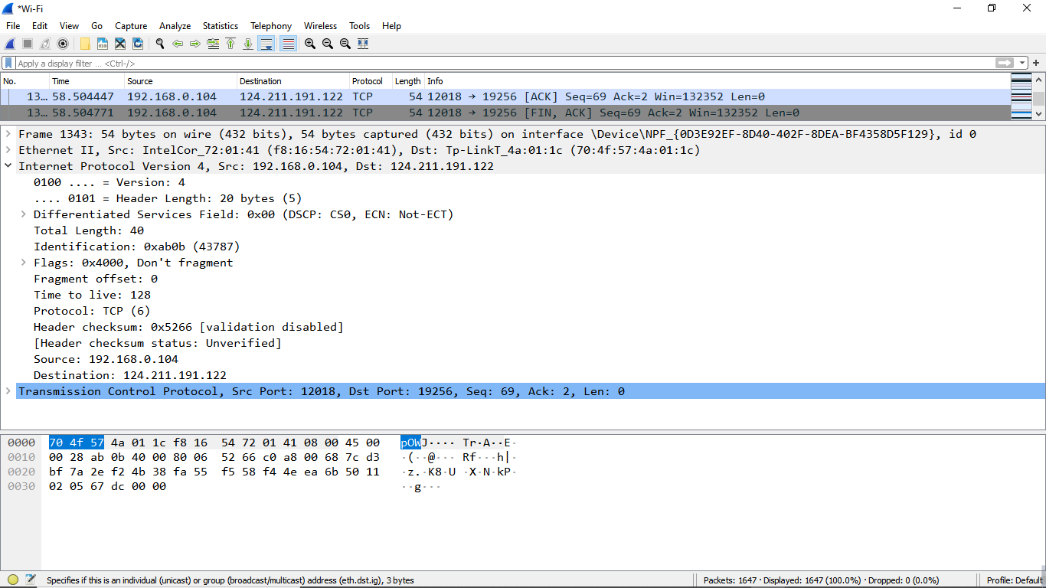

**Figure 07: Packet Details Pane(IP segment)**

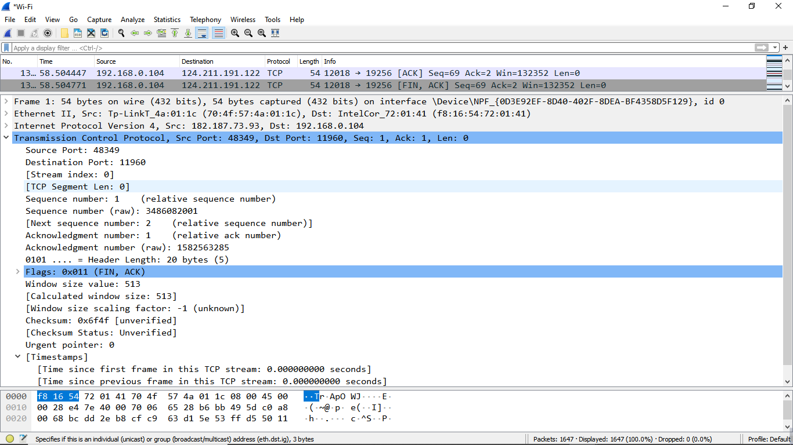

**Figure 08: Packet Details Pane (TCP Segment)**

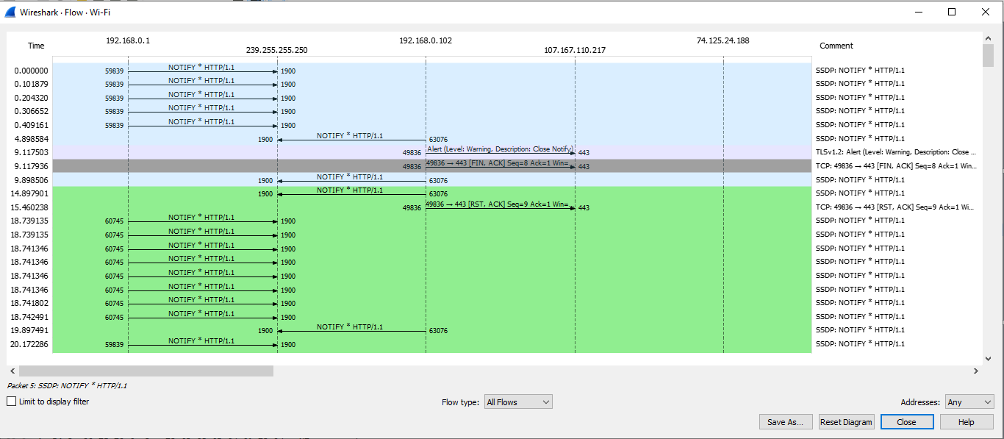

**Figure 09: Statistics- Flow Graph(All Flows)**

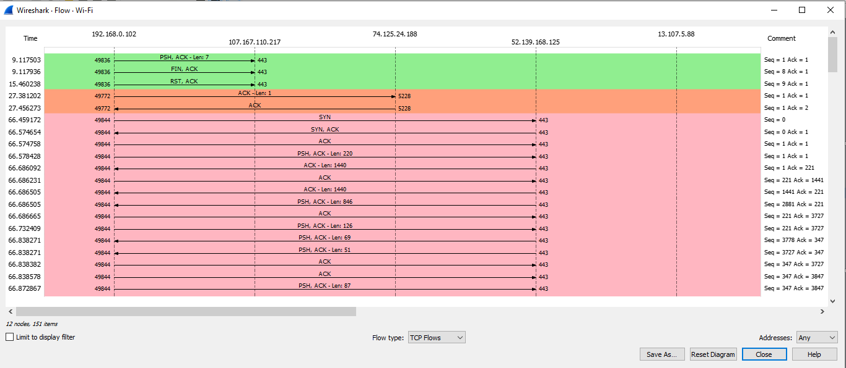

**Figure 13: Statistics- Flow Graph (TCP Flows)**

**Conclusion:**

In this particular experiment we tried capture live packet data from wifi network interface easily using Wireshark. We have applied filter to monitor particular traffic. The TCP Stream Throughput graph have shown us the throughput from one TCP stream, in one direction, based on the selected packet. The experiment was done successfully.